ITA0601 – MACHINE LEARNING
LAB EXPERIMENTS
Exp-3: Implementation of ID3 Decision Tree Algorithm
Aim:
To implement and demonstrate the ID3 (Iterative Dichotomiser 3) Decision Tree Algorithm using an appropriate dataset and classify a new sample.
Procedure:
- Import the required libraries (pandas and DecisionTreeClassifier).
- Create a dataset with input attributes and target class.
- Convert categorical values into numerical values.
- Separate the input features (X) and target labels (Y).
- Train the Decision Tree model using the Entropy criterion (ID3).
- Display the trained Decision Tree.
- Give a new sample as input.
- Predict the class label of the new sample.
- Display the predicted result.
Python Code:
import pandas as pd
from sklearn.preprocessing import LabelEncoder
from sklearn.tree import DecisionTreeClassifier, export_text
data = {
'Outlook': ['Sunny', 'Sunny', 'Overcast', 'Rain', 'Rain',
'Rain', 'Overcast', 'Sunny', 'Sunny', 'Rain',
'Sunny', 'Overcast', 'Overcast', 'Rain'],
'Temperature': ['Hot', 'Hot', 'Hot', 'Mild', 'Cool',
'Cool', 'Cool', 'Mild', 'Cool', 'Mild',
'Mild', 'Mild', 'Hot', 'Mild'],
'Humidity': ['High', 'High', 'High', 'High', 'Normal',
'Normal', 'Normal', 'High', 'Normal', 'Normal',
'Normal', 'High', 'Normal', 'High'],
'Wind': ['Weak', 'Strong', 'Weak', 'Weak', 'Weak',
'Strong', 'Strong', 'Weak', 'Weak', 'Weak',
'Strong', 'Strong', 'Weak', 'Strong'],
'PlayTennis': ['No', 'No', 'Yes', 'Yes', 'Yes',
'No', 'Yes', 'No', 'Yes', 'Yes',
'Yes', 'Yes', 'Yes', 'No']
}
df = pd.DataFrame(data)
print("Training Dataset:\n")
print(df)
encoder = LabelEncoder()
for column in df.columns:
df[column] = encoder.fit_transform(df[column])
X = df.iloc[:, :-1]
Y = df.iloc[:, -1]
model = DecisionTreeClassifier(criterion="entropy")
model.fit(X, Y)
print("\nDecision Tree Rules:\n")
print(export_text(model, feature_names=list(X.columns)))
new_sample = [[2, 2, 0, 1]]
prediction = model.predict(new_sample)
if prediction[0] == 1:
print("\nPrediction: Play Tennis = Yes")
else:
print("\nPrediction: Play Tennis = No")
Output:
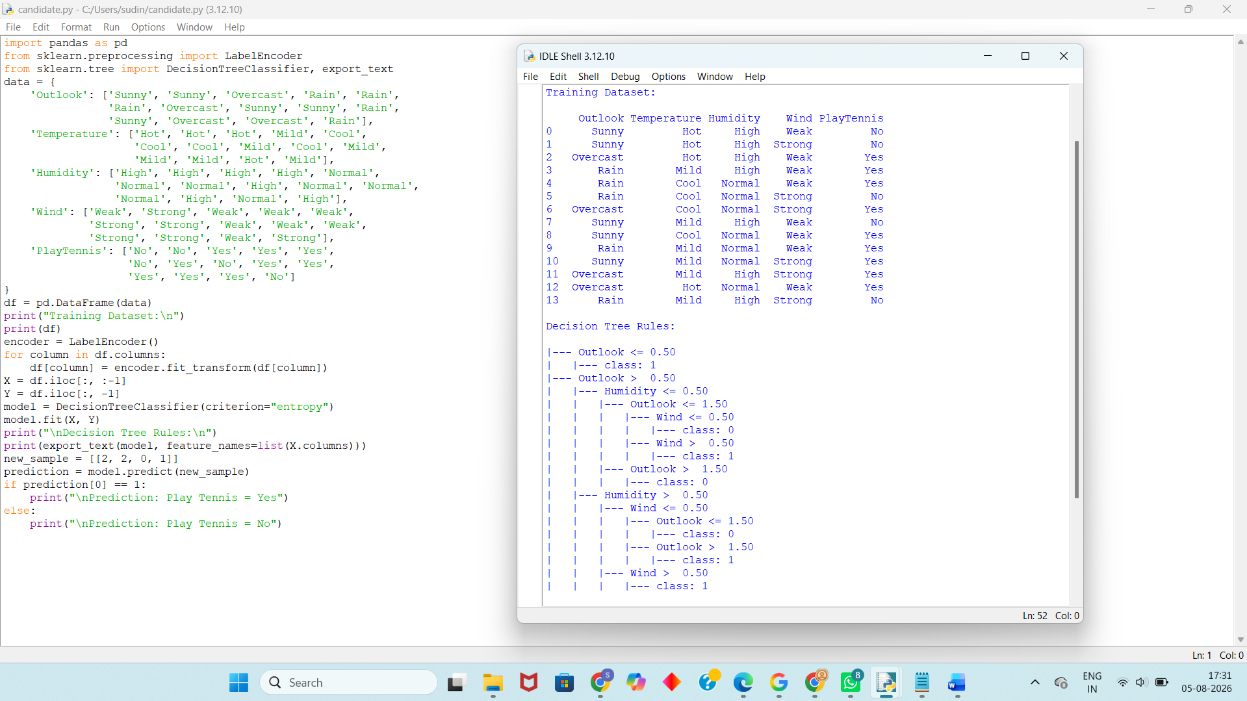
Result:
The ID3 Decision Tree Algorithm was successfully implemented using Python. The decision tree was constructed based on the training dataset using the Entropy criterion, and a new sample was successfully classified as Play Tennis = Yes.

